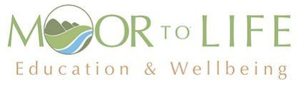

LOtC/Outdoor Education

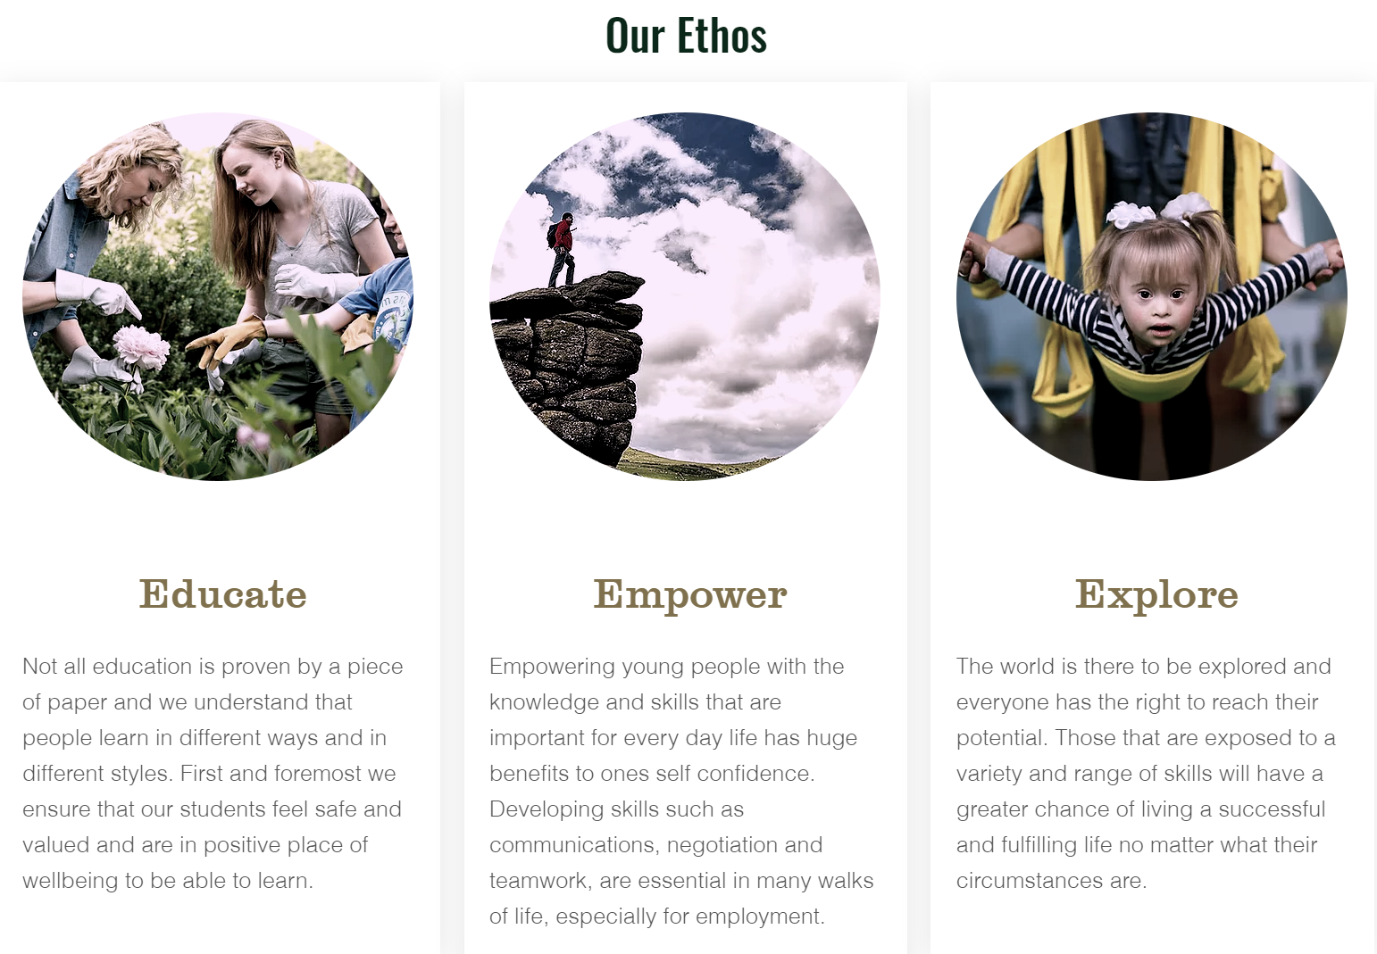

Contents:

- Mission Statement
- Subject policy

Overview of subject and assessment (Methods and application) explaining progression

- Mission Statement
“There is only one thing more painful than learning from experience and that is not learning from experience” Archibald McLeish.

At Moor To Life we believe that every young person should experience the world beyond the classroom as an essential part of learning and personal development, whatever their age, ability or circumstances. These, often the most memorable learning experiences, help us to make sense of the world around us by making links between feelings and learning. They stay with us into adulthood and affect our behaviour, lifestyle and work. They influence our values and the decisions we make. They allow us to transfer learning experienced outside to the classroom and vice versa. At Moor To Life we wish to empower young people with the skills for employment raising their self confidence via a range of activities.

- Subject policy:
Overview of subject

As we are all aware, education is more than the acquisition of knowledge. Improving young people’s understanding, skills, values and personal development can significantly enhance learning and achievement. Learning outside the classroom is not an end in itself, rather, we see it as a vehicle to develop the capacity to learn. It provides a framework for learning that uses surroundings and communities outside the classroom.

This enables young people to explore their own learning and live successfully in the world that surrounds them. There is strong evidence that good quality learning outside the classroom adds much value to classroom learning. It can lead to a deeper understanding of the concepts that span traditional subject boundaries and which are frequently difficult to teach effectively using classroom methods alone. It provides a context for learning in many areas: general and subject based knowledge; thinking and problem-solving skills; life skills such as co-operation and
interpersonal communication.
How we learn
Much has been learnt in recent years about how the brain works and the different ways in which we prefer to learn. Research suggests the need to re-engage learners with the world as they actually experience it. This is often called ‘experiential’ or ‘authentic’ learning. In recent years teachers have been exploring ‘learning how to learn’ in order to raise achievement. What we see, hear, taste, touch, smell and do gives us six main ‘pathways to learning’. Young people are intensely curious and should be given the opportunity to explore the world around them. The potential for learning is maximised if we use the powerful combination of physical, visual and naturalistic ways of learning as well as our linguistic and mathematical intelligence.

Whilst participating in LOtC/Outdoor Education, we would like to base the curriculum around the Duke of Edinburgh’s Award, where the young peoples can (if the correct age) pass different sections whilst learning.

Moor To Life young people attend our provision where they learn vocational skills and participate in different outdoor activities throughout the year gaining proposed awards at the same time:

NICAS L1 or L2 / MTB / Scootering / Abseiling/Outdoor Climbing / DoE Bronze expedition training & NNAS Bronze award and new Outdoor discovery Awards / New British Canoeing Awards / Surfing / Gorge Walking
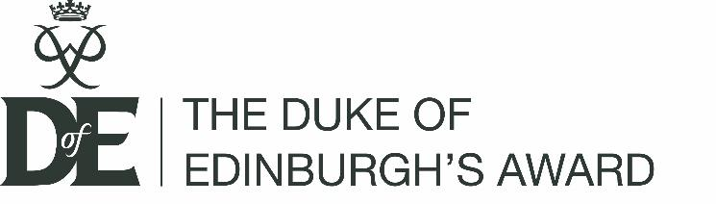
The Duke of Edinburgh’s Award is the world’s leading achievement award
for young people. Its balanced programme of activities which develops the mind, body and soul in an environment of social interaction and team working. It encourages young people to live life as an adventure. The mission of the DoE is ‘To inspire, guide and support young people in their self-development and recognise
their achievements.’

The principles of the DoE are:
- Non-competitive
- Achievable by all
- Voluntary
- Personal development
- Personalised
- Balanced
- Progressive
- Achievement focused
- Demand commitment
- Enjoyable

The benefits are:
- Self-belief
- Self-confidence
- A sense of identity
- Independence of thought and action
- Respect and understanding of people from different backgrounds, cultures and walks of life
- A sense of responsibility
- An awareness of their potential
- New talents and abilities
- An understanding of strengths and weaknesses
- The ability to plan and use time effectively
- The ability to learn from and give to others in the community
- New relationships
- Skills including problem solving, presentation and communication
- The ability to lead and work as part of a team

There are four sections of the Award are:

- Volunteering (MTL Centre – 6 months)
- Physical (Water Sports – Term 3)
- Skills (Climbing – Term 1 &Term 2)
- Expedition

Moor To Life (Voluntary Hours of the DoE)

Young people will be engaging in Learning Outside the Classroom (LOtC) on all the sites that MTL attend to undertake nature exploration, creative tasks and adventure activities. This proposed provision is designed to have measurable benefits. Whilst undertaking this project, the young people should be able to claim hours of voluntary service for their Bronze DoE for at least a 6-month period.

The benefits of this volunteering section are:
- Learn about their community and feel a sense of belonging and purpose
- Learn to take responsibility for their communities and their own actions
- Build new relationships
- Further understand their own strengths and weaknesses
- Develop teamwork and leaderships skills
- Trust others and be trusted
- Enjoy new adventures

The young people will also gain social skills whilst undertaking the projects:

- Interact with public, support staff and instructors
- Build confidence, social awareness and self esteem
- Self-control
- Self-expression
- Self-Accountability
- Respect for others
- Respect for individual difference
- Communication
- Collaboration
- Cooperation/Teamwork
- Trust
- Safety
- Problem Solving
- Honesty/Fairness
- Ethics
- Conflict resolution
- Diligence
- Initiative
- Perseverance

Outdoor Education

Moor To Life young people will undertake proposed activities within the year.

NICAS/NIBAS L1 or L2 – Skills Section of the DoE
DoE Bronze expedition training & NNAS Awards
Water sports – New British Canoeing Awards – Physical Section of the DoE
Scootering – alternative to climbing (Skills Section)
Mountain Biking (MTB) – Alternative Physical Section

Rock Climbing and Abseiling (Outdoor rock climbing and abseiling and indoor climbing at a local climbing wall to gain the NICAS / NIBAS– skills section of the DoE).

The Skills section of the DoE aims ‘To inspire young people to develop practical and social skills and personal interests’. It benefits the young peoples to:

- Develop a new talent
- Improve self-esteem and confidence
- Develop practical and social skills
- Develop better organisational and time management skills
- Sharpen research skills
- Learn how to set and rise to a challenge

The aims of the NICAS schemes link well to the DoE and aim:
• to develop climbing movement skills and improve levels of technical ability
• to learn climbing rope-work, where applicable, and how to use equipment
appropriately
• to develop risk assessment and risk management skills in the sport
• to work as a team, communicate with, and trust a climbing partner
• to provide a structure for development, motivation and improved performance
• to develop an understanding of the sport, its history and ethics
• to appreciate appropriate ways of training with an awareness of injury
prevention, healthfulness, personal insights and wellbeing
• to provide a record of personal achievement
• to point the way to further disciplines and challenges in climbing beyond the
schemes

NIBAS (National Indoor Bouldering Award Scheme) aim:

- to develop climbing movement skills and improve levels of ability
- to learn how to use equipment appropriately
- to develop risk assessment and risk management skills in the sport
- to work as a team, communicate with, and trust other boulderers
- to provide a structure for development, motivation and improved performance
- to develop an understanding of the sport, its history and ethics
- to provide a record of personal achievement
- to point the way to further disciplines and challenges in climbing beyond the scheme

Expedition/Walking (To gain the expedition section of DoE and also to gain an NGB award – National Navigation Award Scheme (NNAS Bronze) & Outdoor Discovery Award (ODA)

The Outdoor Discovery Award (ODA) consist of three levels – 1 Star, 2 Star & 3 Star
At each level the syllabus uses five headings:
- Engage with the outdoors
- Making your own map
- Journeying
- Understanding the concept of symbols and scale
- Setting the map

1 Star
- Make simple maps and sketches to show journeys
- Undertake journeys for fun, using a simple map or plan
- Gain a basic understanding of symbols, scale and map setting

After taking part in the 1 Star ODA, participants will have acquired basic navigational skills and will be able to make short journeys in familiar terrain using their own and other people’s sketches or representations of the area.
2 Star
- Use building interiors and / or the immediate outdoor area when learning skills
- Develop mapping and map setting skills
- Undertake slightly longer journeys, considering scale and distance

After taking part in the 2 Star ODA, participants will be able to make journeys in their local area using their new and revised navigational skills to interpret maps and will have an understanding of standardised symbols.

3 Star
- Plan and follow straightforward journeys around familiar and unfamiliar areas
- Discover and investigate points of interest during the journey
- Understand basic walking safety issues and have respect for the environment

After taking part in the 3 Star ODA, participants should be able to plan and follow journeys in unfamiliar local areas using appropriate maps.
NNAS Bronze Award
The National Navigation Award Scheme will reward the young people with a nationally recognised award. This is a competence basic scheme and assessment where the young peoples will be able to plan and follow routes in the countryside using paths and tracks. The syllabus is as follows:

- Navigate using a variety of maps and scales.
- Use 4 and 6 figure grid references with worded descriptions to define the position of a map feature and to locate a feature on the ground.
- Orientate the map using handrails, obvious point features and major landforms.
- Use linear features (e.g. paths, tracks, clear boundaries) as handrails in simple navigation exercises.
- Relate prominent landforms such as large hills and valleys to corresponding contour information on the map.
- Orientate the map by aligning a compass needle against grid north and be aware that magnetic variation causes an inaccuracy.
- Use an orientated map to confirm direction of travel.
- Use clearly identifiable features to confirm position along the route and to recognise when the target has been overshot.
- Measure horizontal distance on the map and estimate distance on the ground using timing, pacing and simple visual judgements e.g.100m.
- Plan and implement simple routes and navigation strategies based on the above skills.
- Recognise a navigation error within a few minutes and apply simple relocation techniques using handrails and prominent features.
- Demonstrate an awareness of local and national access issues, access legislation, personal responsibilities and the Countryside Code.
- Demonstrate appropriate knowledge of walking equipment, safety equipment and emergency procedures.

At the same time the young people will gain all the skills necessary for undertaking their expedition section of the DoE. The aim of this section is to inspire young people to develop initiative and a sense of adventure and discovery, by planning, training for and completing an adventurous journey as part of a team.
They must complete an unaccompanied, self-reliant expedition with an agreed aim. They must do the correct training for the walking Bronze level, at least one practice expedition, a qualifying expedition (the one that is assessed) and a final presentation in order to complete the section.

Their expedition must be completed by their own physical efforts with minimal external intervention and without motorised assistance. Their route should also be a continuous journey. At Bronze level the expedition is all about young people enjoying the outdoors and teams should avoid using wild country.

Teams must use maps and compasses to navigate during their expedition. The benefits of this section are:

- Gain an appreciation of and respect for the outdoor environment
- Learn the value of sharing responsibility for success
- Learn the importance of attention to detail and organisational ability
- Develop and demonstrate enterprise and imagination
- Become more self-reliant
- Become more able to overcome challenges
- Recognise the needs and strengths of others
- Improve decision-making skills and the ability to accept consequences
- Gain skills to reflect on personal performance
- Learn to manage risk
- Learn through experience

Water Sports (Kayaking/Canoeing/SUP)

This outdoor activity also completes the Physical Section of the DoE where its aim is ‘To inspire young people to achieve greater physical fitness and a healthy lifestyle through participation and improvement in physical activity’.

It benefits the young people by:
- Enjoying keeping fit
- Improving fitness
- Discovering new abilities
- Raising self-esteem
- Extending personal goals
- Setting and respond to a challenge
- Experience a sense of achievement

The young people will be offered coaching to achieve a NGB award. The New British Canoeing Awards are Paddle Start, Paddle Discover and Paddle Explore leading onto the Touring Award for those aged 14+ who have passed the paddle awards:

- Clothing and Equipment
- Getting on the Water
- On the Water
- After the Session
- Future Development

Paddle Start Award

Experience your first session on the water; learning useful skills for an enjoyable paddling experience. It aims to provide you with the basic knowledge to enable you to safely get in and out of your boat, make it move and return to your start point. This is your first step into the world of paddling, ensuring you feel safe, confident and ready to progress to the Discover Award.

Paddle Discover Award

Your Discover Award allows you to develop your decision making and practical skills for a fun and safe time on the water, taking you on the next steps towards becoming a proficient and independent paddler. Learn how to choose and effectively use equipment, whilst developing an understanding of the factors which affect your paddling; giving you the confidence to progress to making your own choices with the Explore Award.

Paddle Explore Award

Your Explore Award gives you ownership; allowing you to choose where you move next in the world of paddlesport. Working with a coach you will be able to develop a programme that suits what you need. Learning to make confident choices with this individualised approach. Recognising your ability to independently paddle your chosen craft in a sheltered water environment.

Touring Award

This award is designed to develop your ability to apply appropriate decision making skills to an enjoyable and safe day out touring. Your Touring Award endorses your skill, judgment and decision making required to have a successful day on a river or estuary. You will be confident in planning and undertaking journeys with proficient skills to be in control throughout. Your award should be seen as a sound basis for building the experience and knowledge associated with the Open Water Touring Award holders.

Scootering – alternative to climbing (skills section)

This is an alternative to climbing and is linked to the Skills section of the DoE aims ‘To inspire young people to develop practical and social skills and personal interests’. It benefits the young peoples to:

- Develop and enhance scootering skills
- Improve self-esteem and confidence
- Develop practical and social skills

Mountain Biking (MTB) – Alternative Physical Section

This is an alternative to water sports where it also completes the Physical Section of the DoE.

MTL Centre (Voluntary Section)

- Assessment of the project for all three terms will be made from the young people’s attendance, participation and evidence of completion of tasks
- A picture log will show progression and assessment for the DoE to complete their voluntary hours under the scheme and update their online log books
- Baseline assessment of their skills (working with tools and constructing) have been undertaken by several members of staff with a pictorial log of their progression
- Formative assessment is ongoing for each week and the success will be shown via their completion of the voluntary section in their DoE logbook

Outdoor Education Assessment

- Assessment of the variety of outdoor activities will be made from the young people’s attendance, participation and continual assessment whilst on activities

NICAS - Also the Skills section of the DoE
- A baseline assessment will be undertaken along with regular formative assessments to ensure the young peoples meet the criteria
- NICAS log books will be updated when a young people is competent at a particular skill and a summative assessment will be conducted prior to booking the NICAS director to sign off the awards
- NICAS levels will be signed off by the NICAS course director (Level 1 & 2 can be undertaken by Bob Watson)
- Entry of information of the skills section will be uploaded to eDoE
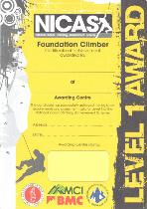
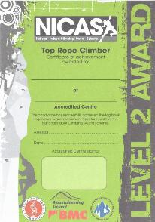

NICAS is a "climbing" award which involves climbing with ropes and harnesses. This is usually done with two people, one climbing, and one holding the rope and lowering the climber (the belayer). Belaying techniques are a key part of NICAS.
Candidates on Level 1 will be expected to be fully backed-up at all times with a gradual introduction of independence into Level 2, where they may be capable of belaying independently.

NNAS

- MTL will apply to run the NNAS (National Navigation Award Scheme)
- A baseline assessment will be undertaken
- Formative assessments will be carried out each week to assess the skills and the young people’s competence. The NNAS tutor will award the qualification

DoE
- The young people must participate in a Bronze expedition (training/practice & assessment) to pass this section of their DoE. The outdoor education department will undertake this assessment and update the on-line DoE (eDoE)

Water Sports

- Water Sports will be undertaken to enable the young people to gain a British Canoeing New Paddle Awards.
- Outdoor education teacher will be able to award the new British Canoeing Awards to the young people providing the young peoples are competent
- Entry of information of the physical section will be uploaded to eDoE

Progress – how we record and show progress

Progression will be recorded for each young person via an excel based system.

For the DoE, this will be recorded with the number of hours (from attendance) and meeting demands of the DoE via the electronic on-line eDoE. This is explained as follows:

Volunteering Section
Volunteering for the community farm is about giving time to something useful, without getting paid. The community farm project has the young peoples mostly in small team where team volunteering can be beneficial to young people and to the project they have chosen. At least 3/4 of the activity needs to be practical volunteering, so only a 1/4 can be training. At the community farm there is some training and the instructor will show how to use tools and construct resources however the majority of the time the young peoples are hands on.

We believe that we have covered two items of this section
- Working with the environment and animals
- Helping community organisation

Progression will be shown via the creative tasks with a pictorial log, mapping to learning outcomes on an excel based system with ‘Working towards, Working at and Mastery’ and completion of the eDoE.

Skills Section
Level 1: New Climber
This is the entry-level award for candidates who wish to learn basic climbing skills. This level focuses on a safety-conscious attitude as much as climbing skills. It is designed to be achievable by any climber with aptitude, whilst remaining under the direct supervision of a coach at all times. A minimum of two climbing sessions, on different days, are required to achieve this level. Guidance on reasonable adjustments which may be made for individual candidates at this level is given in appendix at the back of this logbook.

Progress will be shown via the ‘Working towards, Working at and Mastery’ and completion of the NICAS logbooks.

Level 2: Foundation Climber
This level is a key stage in a climber’s development. It is designed to correspond to most climbing centres’ membership standards. A Level 2 holder should be a potentially independent top rope climber and boulderer. They have mastered the basics of climbing on an artificial climbing structure and should be able to climb and boulder safely and, if appropriate, independently.

Progress will be shown via the ‘Working towards, Working at and Mastery’ and completion of the NICAS logbooks.

Expedition Section
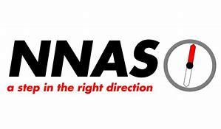
The DoE requires the young peoples to plan, train and complete an adventurous journey as part of a team. In order to achieve these goals, it is necessary to train the young people expedition skills and in navigation and map reading skills, hence the National Navigation Award Scheme Bronze award links well within these goals.

Progress will be shown via the ‘Working towards, Working at and Mastery’ and completion of the NNAS ODA and possibly the Bronze syllabus. Also, progression will be shown by undertaking expedition training and assessment on a residential.

Physical Section
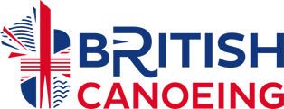
The DoE requires to undertake anything that requires a sustained level of physical energy and involves doing an activity. Participants are free to do this section independently or as part of a team. We have chosen the water sports with undertaking the new British Canoeing Awards:
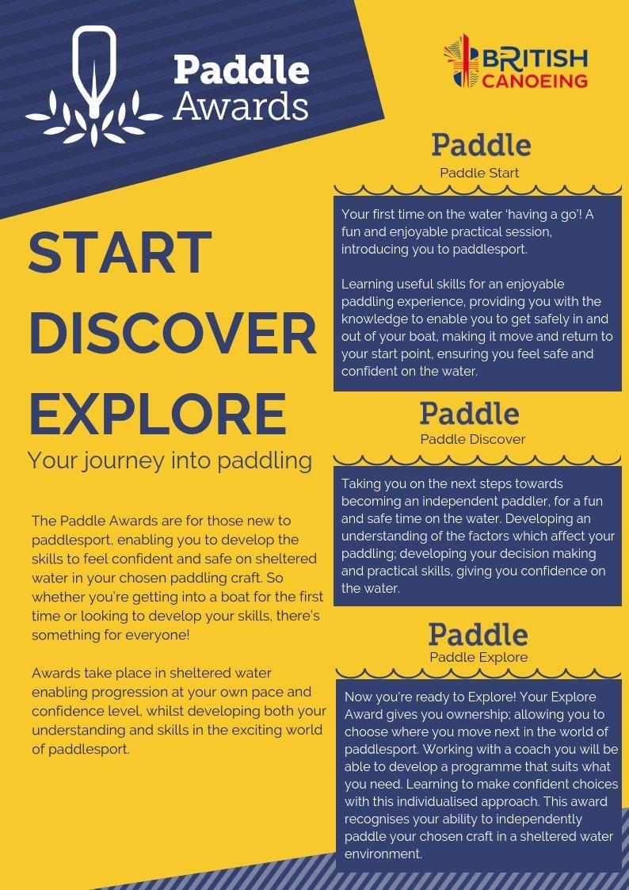
Progress will be shown via the ‘Working towards, Working at and Mastery’ and completion of the new paddle awards syllabus/eDoE.

